Research & Education Trust (RET) Funding Application  To conduct and fund medical imaging research and education that has the objectives of achieving health benefits for the community in New Zealand, and advancing education in the health field in New Zealand.  Please provide all requested information to ensure a timely and accurate decision.  We look forward to collaborating with you. | 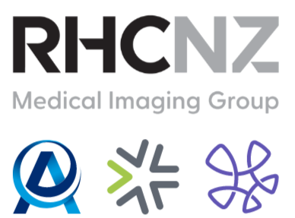

S.1 - Administrative Details
APPLICANT DETAILS
Applicant Name:
Co-Applicant Name:
Organisation:
Application Date:
Address:
Email:
Phone:
SUMMARY OF APPLICATION
Application Title:
Category of Application: | ☐​Research ☐​Education Support ☐​Clinical Trial ☐​Conference ☐​Other  (if other, please specify) ____________________________________________________________
Funding Requested ($):
Summary of Proposal:
explain the main points of your proposal in under 100 words
Commencement Date:
Duration:

S.2 – Proposal Details
DESCRIPTION OF PROPOSAL
Description:
one page max., references encouraged but not required
Objectives:
Background:
Research Design and Methods, or Education Plan, or Programme, or Other:
Scientific/Clinical/Educational Significance or Benefit:
Ethics:  please attach to this application if required and received | Ethics approval required?  ☐ Yes ​☐​ No | Application made?  ☐ Yes ​☐​ No | Approval received?  ☐​ Yes ☐​ No | Ethics Approval Number:
Benefit to the Community:
References:

S.3 Curriculum Vitae
PLEASE ATTACH CURRICULUM VITAE
We recommend you use the NZ-RS&T CV Template.
Please find a guide at:
http://www.hrc.govt.nz/news-and-publications/publications/research-funding
and scroll down to ‘New Zealand Standard Curriculum Vitae Template’.

S.4 Terms and Conditions
TERMS AND CONDITIONS OF FUNDING
If there is more than a six-month delay in actual commencement from the estimated commencement date given, a formal re-application is necessary.
If, at eighteen months, there is no activity regarding the funds, the RET has the right to withdraw funding unless there are exceptional circumstances notified to the Trustees.
Recipients to provide final study output and/or a one-page report to be presented to the RET Trustees at the conclusion of the study. Please elect type of output:
☐​Scientific Journal ☐​Electronic Presentation ☐​Conference/Local Presentation ☐​Scientific Poster ☐​Other_______________________________

Recipients consent to be contacted by RHCNZ representatives and to the use of any project outcome material for marketing and promotional activities.
RHCNZ support is to be formally acknowledged in any subsequent publications and the RET wish to be informed of any intended publications at each stage of the drafting, submission and acceptance process.

Once completed, please email to the RHCNZ Research & Education Trust Secretary at:
RETadmin@rhcnz.com

Please ensure that all fields are completed and accurate to avoid the form being returned.

